# PERFORMANCE AND FINAL SUBMISSION PHASE

|  |  |
| --- | --- |
| **Date** | **01 Nov 2023** |
| **Team ID** | **NM2023TMID05793** |
| **Project Name** | **Create an email campaign in mail chimp** |

**1.MODEL PERFORMANCE METRICS**

# STEP 1: GO TO MAIL CHIMP IN YOUR BROWSER

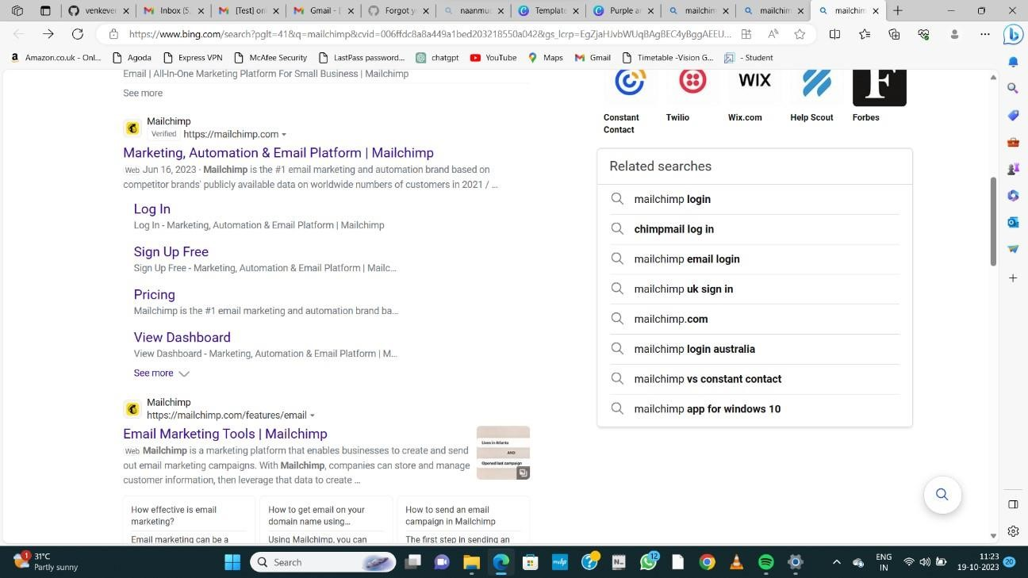

# STEP 2:LOGIN TO YOUR MAIL CHIMP ACCOUNT

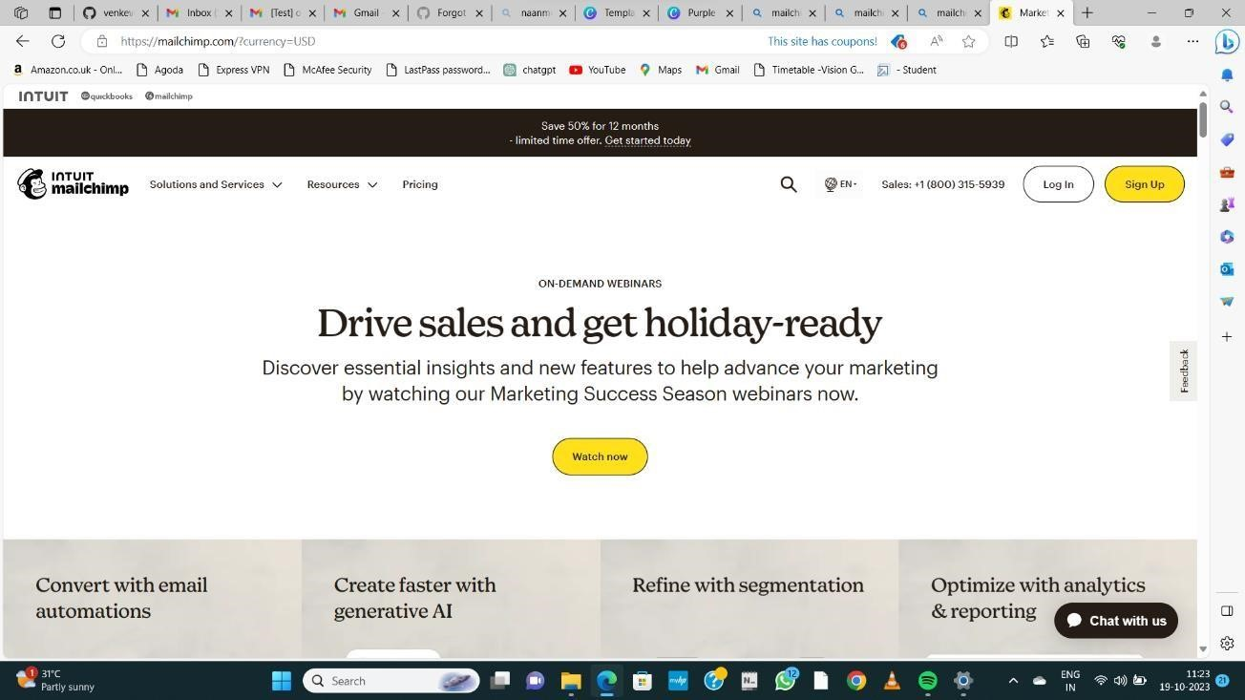

# STEP 3: LOGIN WITH FREE ACCOUNT

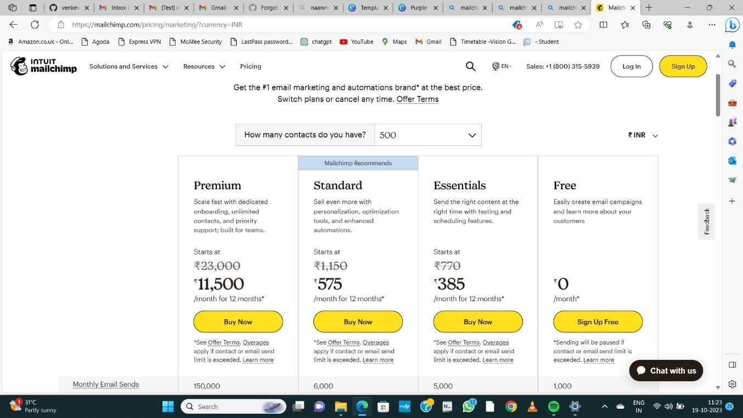

# STEP 4: LOGIN INTO MAILCHIMP

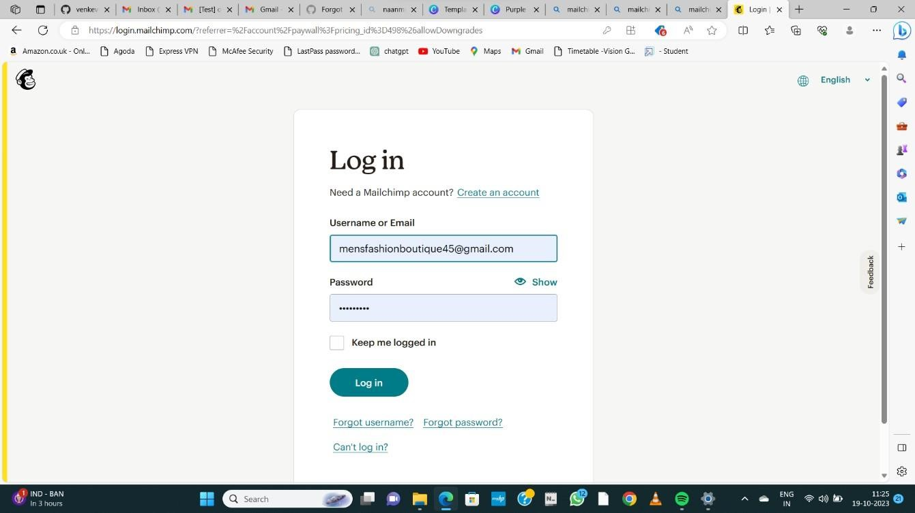

# Step 5: go to create to create a new email newsletter

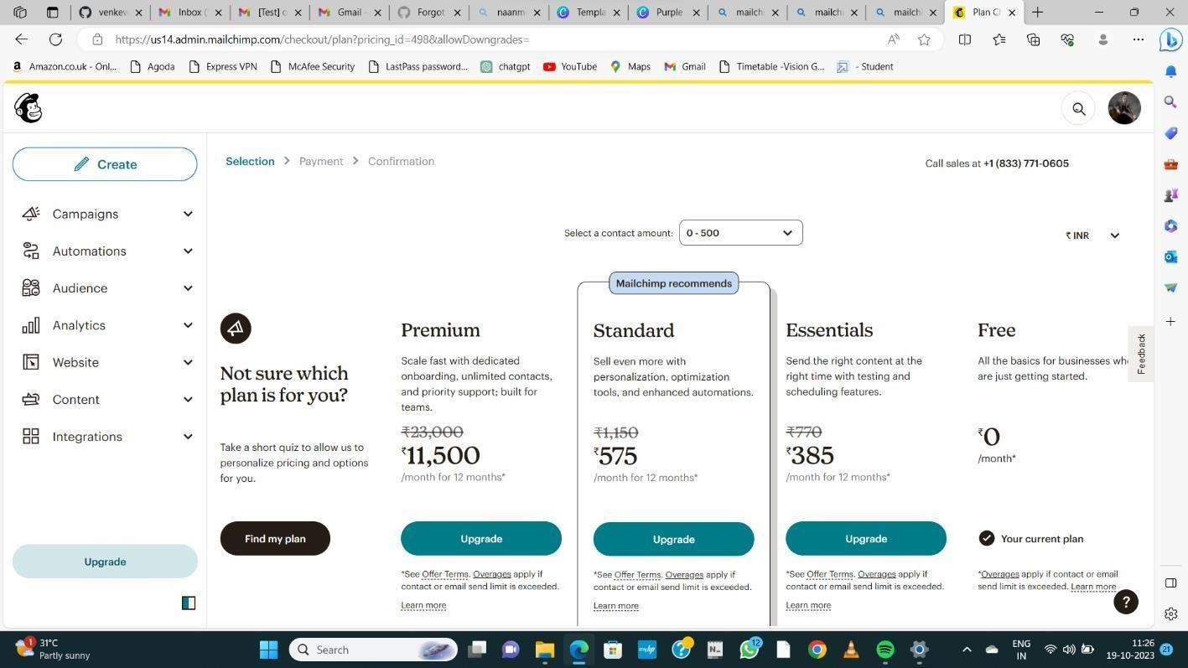

# STEP 6: CLICK DESIGN EMAIL

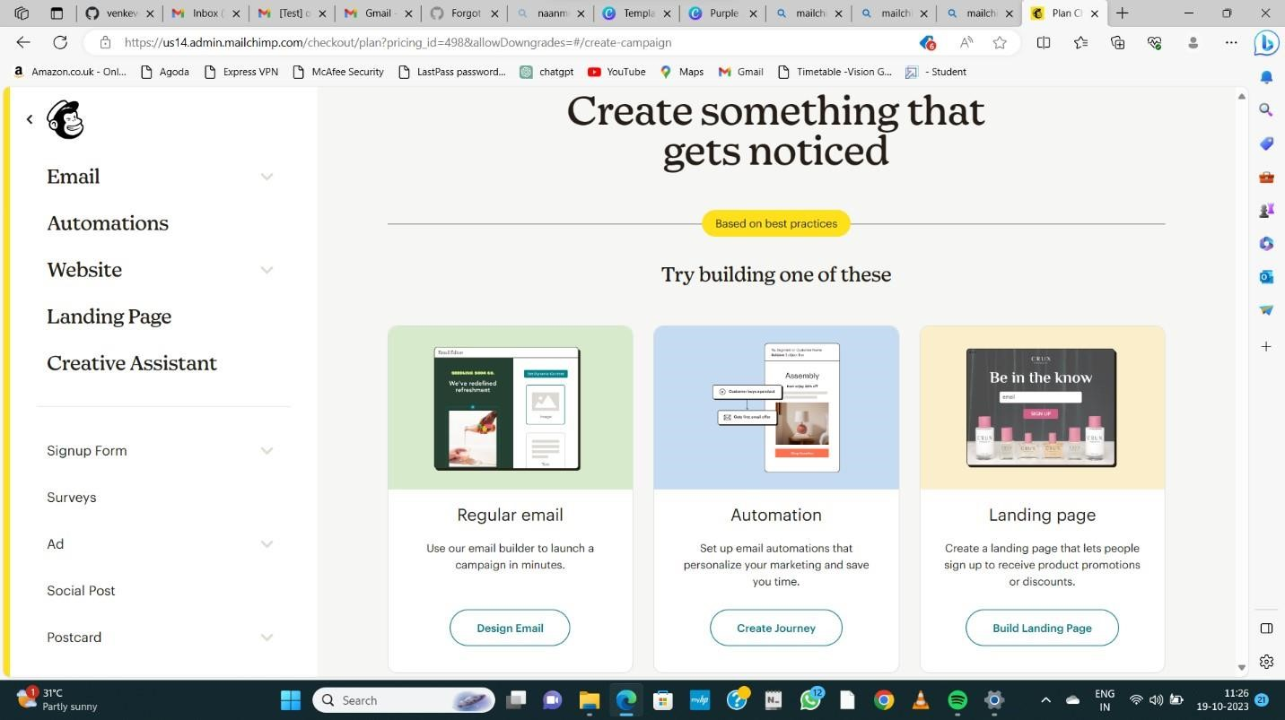

**STEP 7: ADD FROM, TO, SUBJECT AND**

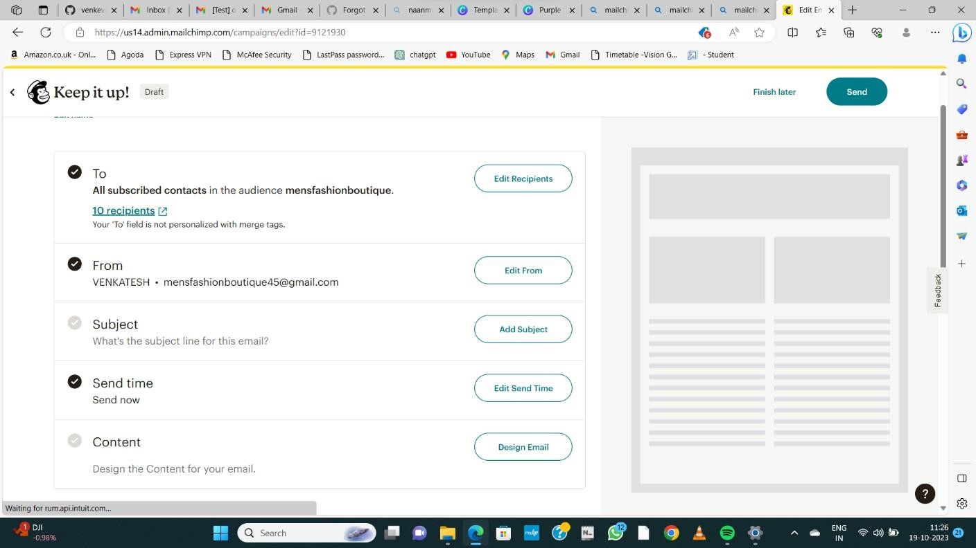

# STEP 8: SELECT ANY 1 DEAFULT TEMPLATE

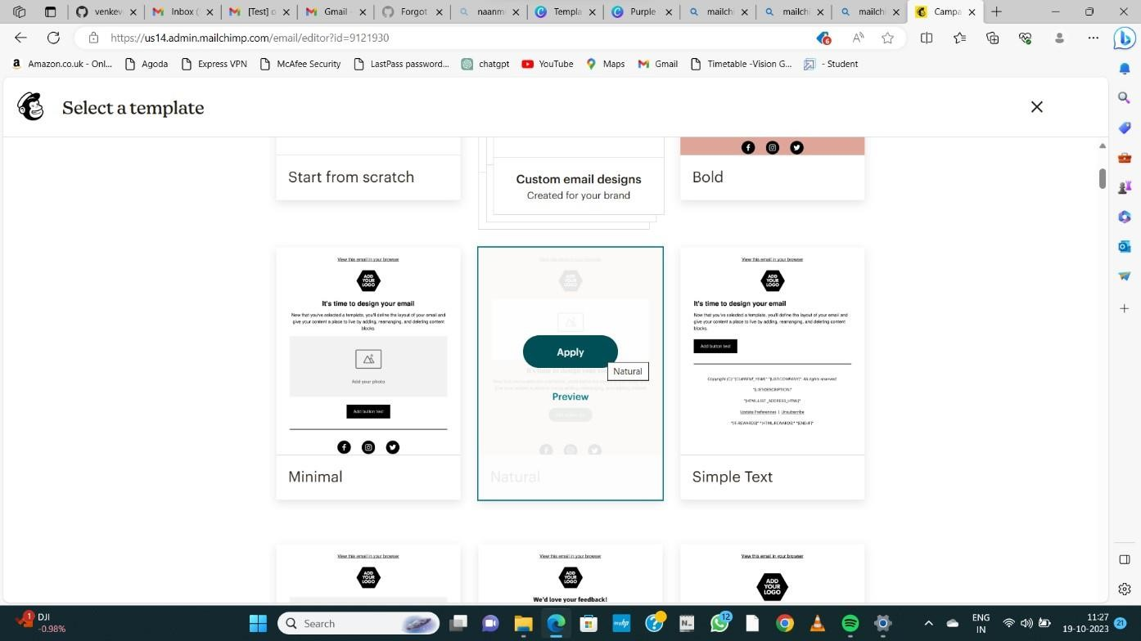

**STEP 9: ADD LOGO AND OTHER CHANGES CLICK SAVE AND EXIT**

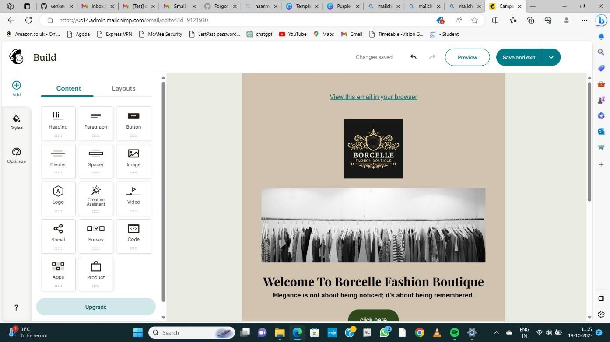

# STEP 10: NOW SEND A TEST MAIL BY GIVING A RECIPIENTS

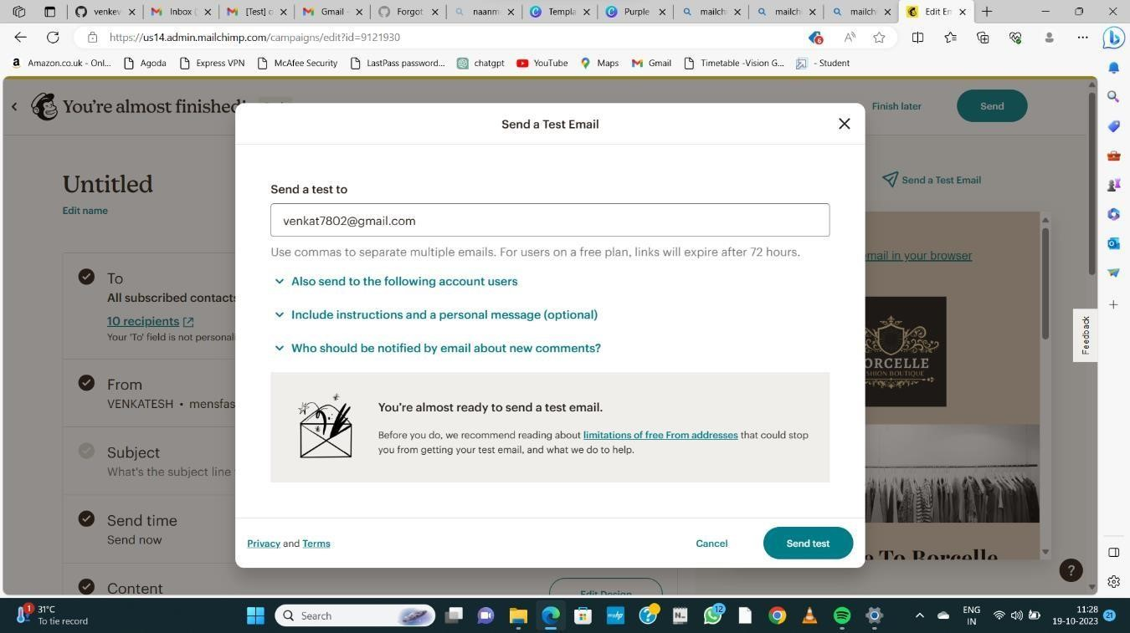

**STEP 11: CONFIRMATION RECEIVED**

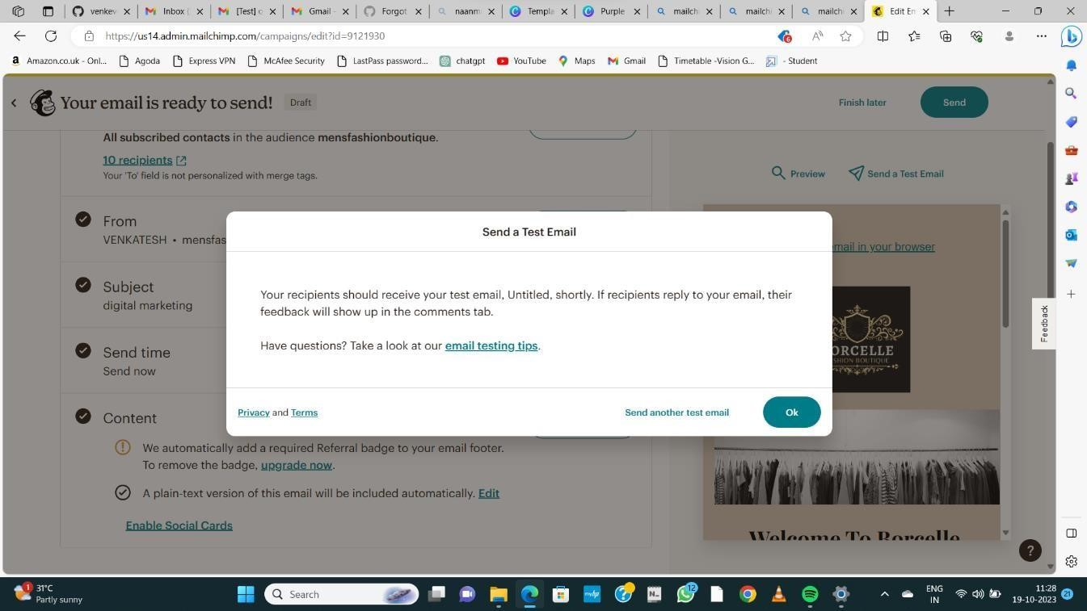

**STEP 12: GO TO GIVEN EMAIL AND DOWNLOAD TEST MAIL**

